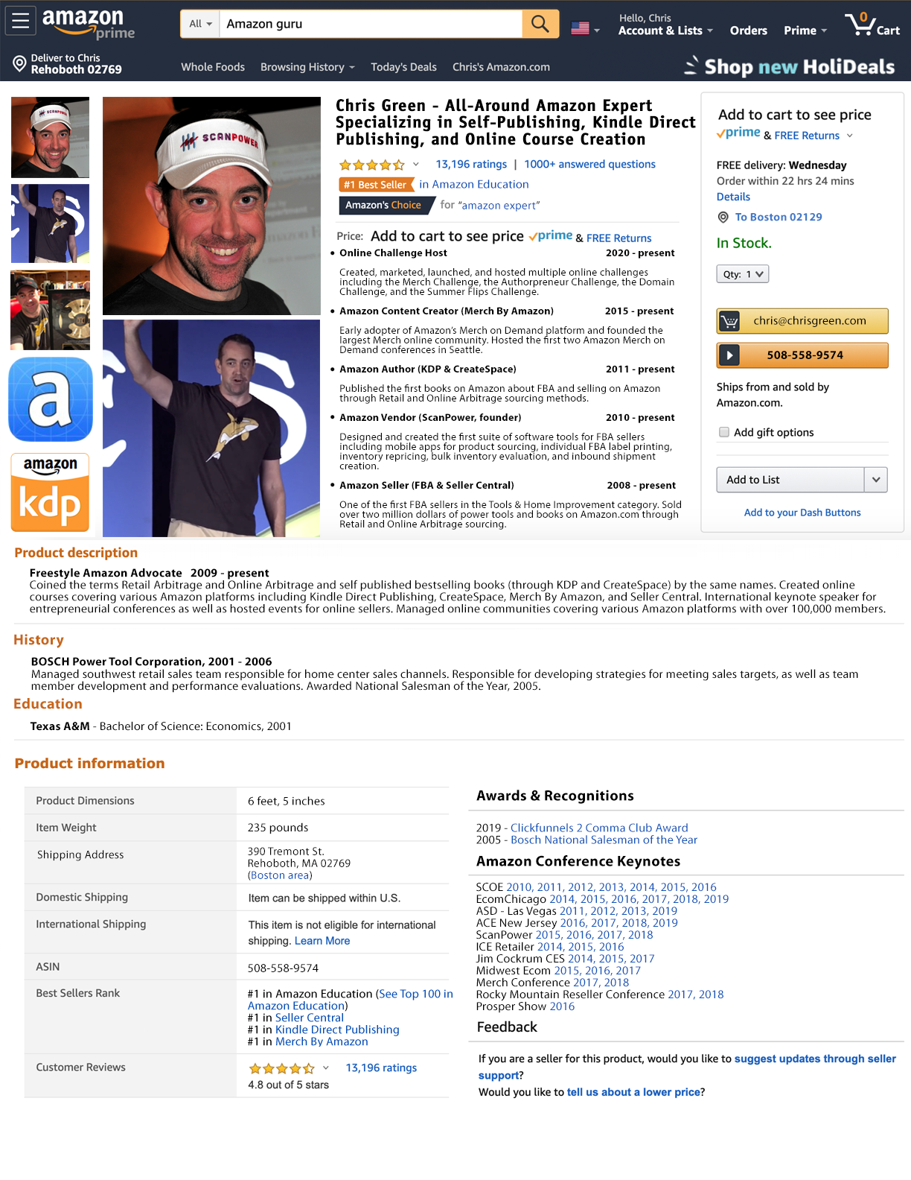


Chris Green
390 Tremont St.
Rehoboth, MA 02769
508-558-9574
chris@chrisgreen.com
facebook.com/chris

This isn’t a typical resume because the past 18 years have not been typical.

After graduating from Texas A&M in 2001, I worked in sales for Bosch Power Tools where I won their National Salesman of the Year Award in 2005. I left Bosch in 2006 and since then I’ve been a self-employed entrepreneur and part of SIX different businesses related to Amazon (including self-publishing) that each did over $1,000,000 in sales.

And I can honestly say that self-publishing is the most powerful of all the Amazon platforms, BY FAR.

After I published my first book about selling on Amazon in 2011 (Retail Arbitrage), I instantly understood the POWER of self-publishing. I’ve seen firsthand how becoming a published author on Amazon can open so many doors and also lead to some incredible business and networking opportunities.

My specialty has become helping people and businesses find new, creative, and even non-traditional ways to strategically use self-publishing to differentiate themselves from their competitors as well as for lead generation, establishing industry authority, and publishing online course content as Prime-eligible physical products on Amazon.

I’ve coached thousands of people personally as well as through my online courses and challenges. I know that a lot of people believe that self-publishing is too hard, too expensive, or that they aren’t good enough, or that someone else has already done it better. I know how to help people overcome these kinds of limiting beliefs and turn them into published authors.

Self-publishing is only getting bigger, better, and even more powerful and I want to be a part of it.

I want to help as many people as possible get their words, their stories, and their knowledge PUBLISHED and out into the world. I’m not joking when I say that I will talk to anyone who will listen about self-publishing. I love everything about this business and I want to be a part of a team that creates and empowers more people to become published authors.

Simultaneously the #1, #2, #3, and #4  Best Sellers in Entrepreneurship | $70,000 KDP Royalty Check  (Launch of Online Arbitrage book)
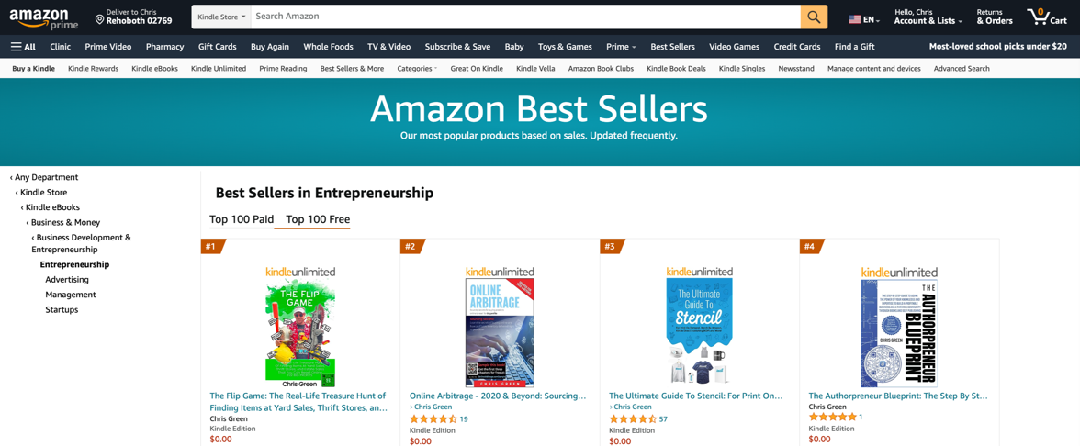 | 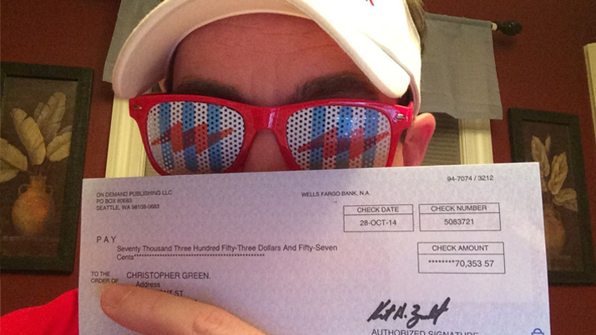
https://amazon.com/author/chris

Over 80,000 Udemy Students  (4.3/5 stars, 2,700+ reviews) | 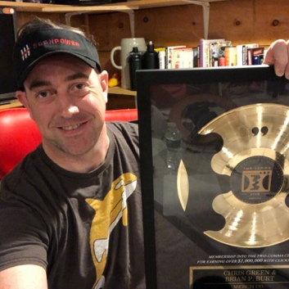
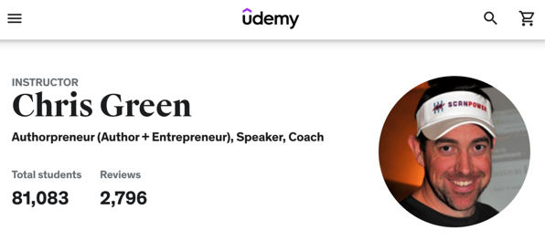
https://www.udemy.com/user/chrisgreen21 | 2 Comma Club Award Winner (2019)

